Тема № 8
Разработка игры с элементами графики
Цель работы: получить практические навыки разработки игровых форм с геймплейной реализацией элементов графики.
Задача (16 вариант):
Игра «Летящая ракета».
Разработать графическую игру, включающую изображение летящей ракеты и движущихся метеоритов. Ракетой можно управлять с помощью стрелок на клавиатуре. Пользователь должен успеть отклонить ракету от приближающихся крупных метеоритов, а мелкие «собрать», успев нажать на определенную клавишу (например, Enter). Игра продолжается определенное время, в течение которого надо собрать заданное количество мелких метеоритов и не столкнуться с большими.
Программа демонстрирует работу с графикой.
Задание 1:
Код главной формы
using System;
using System.Collections.Generic;
using System.ComponentModel;
using System.Data;
using System.Drawing;
using System.IO;
using System.Linq;
using System.Net.Sockets;
using System.Runtime.Serialization.Formatters.Binary;
using System.Text;
using System.Threading.Tasks;
using System.Windows.Forms;

namespace Task8
{
public partial class MainForm : Form
{
private Rocket rocket;
private List<Meteor> meteors = new List<Meteor>();
private string currentLogin;
// Параметры игры
private GameSettings settings;
private int currentScore = 0;
private int remainingTime;
private bool isGameActive = false;
public MainForm()
{
InitializeComponent();
LoadDefaultSettings();
ShowLoginDialog();
ApplySettings();

this.newGameMenuItem.Click += NewGameMenuItem_Click;
this.exitMenuItem.Click += ExitMenuItem_Click;
this.settingsMenuItem.Click += SettingsMenuItem_Click;
this.resultsMenuItem.Click += ResultsMenuItem_Click;
this.helpMenuItem.Click += HelpMenuItem_Click;
this.KeyDown += MainForm_KeyDown;
this.gamePanel.Paint += GamePanel_Paint;
}

private void LoadDefaultSettings()
{
settings = new GameSettings();
}

private void ShowLoginDialog()
{
using (LoginForm lf = new LoginForm())
{
if (lf.ShowDialog() == DialogResult.OK)
currentLogin = lf.Login;
else
currentLogin = "Guest";
}
}

private void ApplySettings()
{
gamePanel.Invalidate();
}
private void NewGameMenuItem_Click(object sender, EventArgs e)
{
StartGame();
}

private void ExitMenuItem_Click(object sender, EventArgs e)
{
Application.Exit();
}

private void SettingsMenuItem_Click(object sender, EventArgs e)
{
using (SettingsForm sf = new SettingsForm(settings))
{
if (sf.ShowDialog() == DialogResult.OK)
{
settings = sf.Settings;
}
}
}

private void ResultsMenuItem_Click(object sender, EventArgs e)
{
using (ResultForm rf = new ResultForm(currentLogin))
{
rf.ShowDialog();
}
}

private void HelpMenuItem_Click(object sender, EventArgs e)
{
MessageBox.Show("Управление: стрелки влево/вправо – движение ракеты.\n" +
"Enter – собрать мелкий метеорит (при пересечении с ракетой).\n" +
"Избегайте крупных красных метеоритов!\n" +
"Соберите заданное количество жёлтых метеоритов до истечения времени.",
"Справка", MessageBoxButtons.OK, MessageBoxIcon.Information);
}
private void StartGame()
{
StopGame();

meteors.Clear();
currentScore = 0;
remainingTime = settings.TimeSeconds;
isGameActive = true;
UpdateStatus();

int rocketWidth = 40;
int rocketHeight = 30;
int startX = gamePanel.Width / 2 - rocketWidth / 2;
rocket = new Rocket(startX, gamePanel.Height - rocketHeight - 20, rocketWidth, rocketHeight);

gameTimer = new System.Windows.Forms.Timer();
gameTimer.Interval = 30;
gameTimer.Tick += GameTimer_Tick;

spawnTimer = new System.Windows.Forms.Timer();
spawnTimer.Interval = settings.SpawnIntervalMs;
spawnTimer.Tick += SpawnTimer_Tick;

countdownTimer = new System.Windows.Forms.Timer();
countdownTimer.Interval = 1000;
countdownTimer.Tick += CountdownTimer_Tick;

gameTimer.Start();
spawnTimer.Start();
countdownTimer.Start();

gamePanel.Invalidate();
}

private void StopGame()
{
isGameActive = false;
if (gameTimer != null) gameTimer.Stop();
if (spawnTimer != null) spawnTimer.Stop();
if (countdownTimer != null) countdownTimer.Stop();
}
private void GameTimer_Tick(object sender, EventArgs e)
{
if (!isGameActive) return;

for (int i = meteors.Count - 1; i >= 0; i--)
{
Meteor m = meteors[i];
m.Y += m.Speed;
if (m.Y > gamePanel.Height + 50 || m.Y + m.Size < 0)
{
meteors.RemoveAt(i);
continue;
}
if (m.Type == MeteorType.Large && rocket.GetBounds().IntersectsWith(m.GetBounds()))
{
EndGame(false);
return;
}
}

if (currentScore >= settings.TargetMeteors)
{
EndGame(true);
return;
}

gamePanel.Invalidate();
}

private void SpawnTimer_Tick(object sender, EventArgs e)
{
if (!isGameActive) return;
Random rand = new Random();
MeteorType type = (rand.NextDouble() < settings.LargeMeteorProbability) ? MeteorType.Large : MeteorType.Small;
int size = (type == MeteorType.Large) ? 35 : 18;
int x = rand.Next(0, gamePanel.Width - size);
int y = -size;
int speed = settings.MeteorBaseSpeed + rand.Next(2, 6);
meteors.Add(new Meteor(x, y, size, speed, type));
}

private void CountdownTimer_Tick(object sender, EventArgs e)
{
if (!isGameActive) return;
remainingTime--;
UpdateStatus();
if (remainingTime <= 0) EndGame(false);
}

private void UpdateStatus()
{
scoreLabel.Text = $"Собрано: {currentScore} / {settings.TargetMeteors}";
timeLabel.Text = $"Время: {remainingTime}";
}

private void EndGame(bool isWin)
{
if (!isGameActive) return;
isGameActive = false;
StopGame();

string message = isWin ? $"Победа! Вы собрали {currentScore} метеоритов!" : $"Поражение! Собрано {currentScore} из {settings.TargetMeteors}.";
MessageBox.Show(message, "Конец игры", MessageBoxButtons.OK, MessageBoxIcon.Information);
SaveResult(isWin);
}
private void SaveResult(bool isWin)
{
GameResult result = new GameResult
{
Login = currentLogin,
Date = DateTime.Now,
Score = currentScore,
Required = settings.TargetMeteors,
IsWin = isWin
};

string file = "results.dat";
List<GameResult> results = new List<GameResult>();
if (File.Exists(file))
{
BinaryFormatter bf = new BinaryFormatter();
using (FileStream fs = new FileStream(file, FileMode.Open))
{
results = (List<GameResult>)bf.Deserialize(fs);
}
}
results.Add(result);
BinaryFormatter bfOut = new BinaryFormatter();
using (FileStream fs = new FileStream(file, FileMode.Create))
{
bfOut.Serialize(fs, results);
}
}

private void CollectSmallMeteor()
{
if (!isGameActive) return;
for (int i = meteors.Count - 1; i >= 0; i--)
{
Meteor m = meteors[i];
if (m.Type == MeteorType.Small && rocket.GetBounds().IntersectsWith(m.GetBounds()))
{
meteors.RemoveAt(i);
currentScore++;
UpdateStatus();
if (currentScore >= settings.TargetMeteors) EndGame(true);
break;
}
}
gamePanel.Invalidate();
}

private void MainForm_KeyDown(object sender, KeyEventArgs e)
{
if (!isGameActive) return;
if (e.KeyCode == Keys.Left)
{
rocket.X -= settings.RocketSpeed;
if (rocket.X < 0) rocket.X = 0;
gamePanel.Invalidate();
}
else if (e.KeyCode == Keys.Right)
{
rocket.X += settings.RocketSpeed;
if (rocket.X + rocket.Width > gamePanel.Width) rocket.X = gamePanel.Width - rocket.Width;
gamePanel.Invalidate();
}
else if (e.KeyCode == Keys.Enter)
{
CollectSmallMeteor();
}
}

private void GamePanel_Paint(object sender, PaintEventArgs e)
{
if (rocket != null)
rocket.Draw(e.Graphics, settings.RocketColor);
foreach (Meteor m in meteors)
{
Color color = (m.Type == MeteorType.Large) ? settings.LargeMeteorColor : settings.SmallMeteorColor;
m.Draw(e.Graphics, color);
}
}

}
public enum MeteorType { Large, Small }

public class Rocket
{
public int X { get; set; }
public int Y { get; set; }
public int Width { get; private set; }
public int Height { get; private set; }

public Rocket(int x, int y, int width, int height)
{
X = x; Y = y; Width = width; Height = height;
}

public Rectangle GetBounds() => new Rectangle(X, Y, Width, Height);

public void Draw(Graphics g, Color color)
{
using (SolidBrush brush = new SolidBrush(color))
{
g.FillRectangle(brush, X, Y + Height / 3, Width, Height * 2 / 3);
Point[] nose = { new Point(X + Width / 2, Y), new Point(X, Y + Height / 3), new Point(X + Width, Y + Height / 3) };
g.FillPolygon(brush, nose);
using (Brush white = new SolidBrush(Color.White))
g.FillEllipse(white, X + Width / 2 - 5, Y + Height / 2, 10, 10);
}
}
}

public class Meteor
{
public int X { get; set; }
public int Y { get; set; }
public int Size { get; private set; }
public int Speed { get; set; }
public MeteorType Type { get; private set; }

public Meteor(int x, int y, int size, int speed, MeteorType type)
{
X = x; Y = y; Size = size; Speed = speed; Type = type;
}

public Rectangle GetBounds() => new Rectangle(X, Y, Size, Size);

public void Draw(Graphics g, Color color)
{
using (SolidBrush brush = new SolidBrush(color))
g.FillEllipse(brush, X, Y, Size, Size);
using (Brush dark = new SolidBrush(Color.Black))
{
g.FillEllipse(dark, X + Size / 4, Y + Size / 4, Size / 6, Size / 6);
g.FillEllipse(dark, X + Size * 2 / 3, Y + Size / 3, Size / 8, Size / 8);
}
}
}
}
Класс значений настроек GameSettings
using System;
using System.Drawing;

namespace Task8
{
public enum Difficulty { Easy, Medium, Hard }

[Serializable]
public class GameSettings
{
public int TimeSeconds { get; set; } = 60;
public int TargetMeteors { get; set; } = 10;
public Difficulty Difficulty { get; set; } = Difficulty.Medium;
public Color RocketColor { get; set; } = Color.Green;
public Color LargeMeteorColor { get; set; } = Color.Red;
public Color SmallMeteorColor { get; set; } = Color.Yellow;
public int RocketSpeed { get; set; } = 12;
public int MeteorBaseSpeed { get; set; } = 5;
public int SpawnIntervalMs { get; set; } = 800;
public float LargeMeteorProbability { get; set; } = 0.3f;
}
}

Код формы настроек
using System;
using System.Collections.Generic;
using System.ComponentModel;
using System.Data;
using System.Drawing;
using System.Linq;
using System.Text;
using System.Threading.Tasks;
using System.Windows.Forms;

namespace Task8
{
public partial class SettingsForm : Form
{
public GameSettings Settings { get; private set; }
public SettingsForm(GameSettings currentSettings)
{
InitializeComponent();
Settings = currentSettings;
LoadSettings();

// Подписка на события
btnSave.Click += btnSave_Click;
btnRocketColor.Click += btnColor_Click;
btnLargeColor.Click += btnColor_Click;
btnSmallColor.Click += btnColor_Click;
}

private void LoadSettings()
{
numTime.Value = Settings.TimeSeconds;
numTarget.Value = Settings.TargetMeteors;
cmbDifficulty.SelectedIndex = (int)Settings.Difficulty-1;
btnRocketColor.BackColor = Settings.RocketColor;
btnLargeColor.BackColor = Settings.LargeMeteorColor;
btnSmallColor.BackColor = Settings.SmallMeteorColor;
}

private void btnSave_Click(object sender, EventArgs e)
{
Settings.TimeSeconds = (int)numTime.Value;
Settings.TargetMeteors = (int)numTarget.Value;
Settings.Difficulty = (Difficulty)cmbDifficulty.SelectedIndex;
Settings.RocketColor = btnRocketColor.BackColor;
Settings.LargeMeteorColor = btnLargeColor.BackColor;
Settings.SmallMeteorColor = btnSmallColor.BackColor;

// Обновляем параметры в зависимости от сложности
switch (Settings.Difficulty)
{
case Difficulty.Easy:
Settings.MeteorBaseSpeed = 3;
Settings.SpawnIntervalMs = 1200;
Settings.LargeMeteorProbability = 0.2f;
break;
case Difficulty.Medium:
Settings.MeteorBaseSpeed = 5;
Settings.SpawnIntervalMs = 800;
Settings.LargeMeteorProbability = 0.3f;
break;
case Difficulty.Hard:
Settings.MeteorBaseSpeed = 7;
Settings.SpawnIntervalMs = 500;
Settings.LargeMeteorProbability = 0.4f;
break;
}
DialogResult = DialogResult.OK;
Close();
}

private void btnColor_Click(object sender, EventArgs e)
{
Button btn = sender as Button;
using (ColorDialog cd = new ColorDialog())
{
if (cd.ShowDialog() == DialogResult.OK)
btn.BackColor = cd.Color;
}
}
}
}

Вид формы:
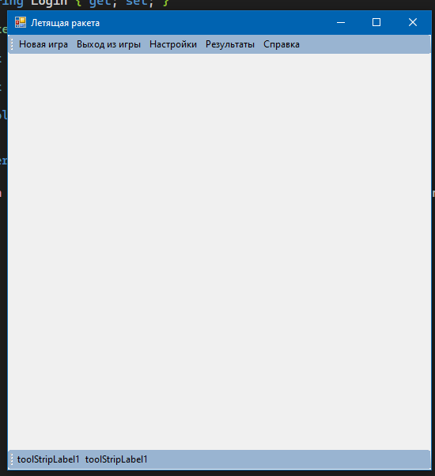
Рис.1 – Вид чистой формы
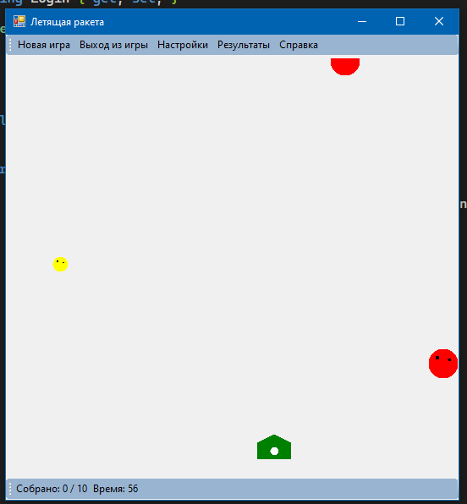
Рис.2 – Вид формы во время игры
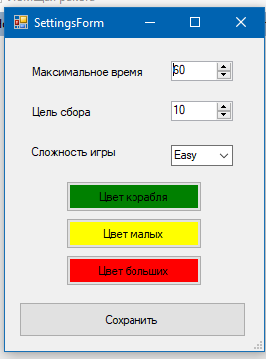
Рис.3 – Вид формы настроек
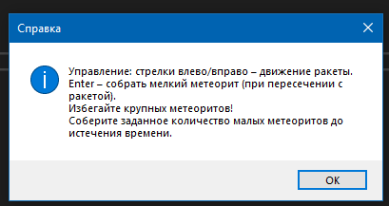
Рис.4 – Справка
Задание 2:
Код формы Логина LoginForm.cs
using System;
using System.Collections.Generic;
using System.ComponentModel;
using System.Data;
using System.Drawing;
using System.Linq;
using System.Text;
using System.Threading.Tasks;
using System.Windows.Forms;

namespace Task8
{
public partial class LoginForm : Form
{
public string Login { get; private set; }
public LoginForm()
{
InitializeComponent();
}

private void btnConfirm_Click(object sender, EventArgs e)
{
Login = txtLogin.Text.Trim();
if (string.IsNullOrEmpty(Login))
Login = "Guest";
DialogResult = DialogResult.OK;
Close();
}
}
}
Код класса для результатов
using System;

namespace Task8
{
[Serializable]
public class GameResult
{
public string Login { get; set; }
public DateTime Date { get; set; }
public int Score { get; set; } // сколько собрано
public int Required { get; set; } // сколько требовалось
public bool IsWin { get; set; }

public override string ToString()
{
return $"{Date:dd.MM.yyyy HH:mm:ss} | {Score}/{Required} | {(IsWin ? "Победа" : "Поражение")}";
}
}
}
Код формы результатов
using System.Linq;
using System.Runtime.Serialization.Formatters.Binary;
using System.Text;
using System.Threading.Tasks;
using System.Windows.Forms;

namespace Task8
{
public partial class ResultForm : Form
{
private string login;
private List<GameResult> allResults;
public ResultForm(string currentLogin)
{
InitializeComponent();
login = currentLogin;
LoadResults();
}

private void LoadResults()
{
string file = "results.dat";
if (File.Exists(file))
{
BinaryFormatter bf = new BinaryFormatter();
using (FileStream fs = new FileStream(file, FileMode.Open))
{
allResults = (List<GameResult>)bf.Deserialize(fs);
}
}
else
allResults = new List<GameResult>();

var myResults = allResults.FindAll(r => r.Login.Equals(login, StringComparison.OrdinalIgnoreCase));
listBoxResults.DataSource = myResults;
listBoxResults.DisplayMember = "ToString";
}
}
}
Вид форм для 2 задания
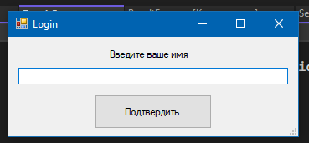
Рис.5 – Форма логина
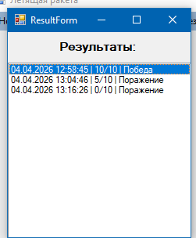
Рис.6 – Форма результатов

